**Project Title:** A Mile High Look At The Air We Breathe - Visualizing Air Quality in Colorado

**Team Members:**

* Melissa Schafer
* Renee White
* Dylan Robb
* Will Serene
* AJ Paine

**Description:**

Interactive dashboard showing air quality data for the state of Colorado.

* Gauge for air index quality
* Trend molecule concentrations over time
* Heatmap with layers for each concentration

**Future Work:**

* Incorporate water quality
* Expand outside of CO
* Incorporate drought conditions

**Potential Datasets and a screenshot of the metadata if it exists**

<https://openweathermap.org/api/air-pollution>

<https://www.colorado.gov/airquality/default.aspx>

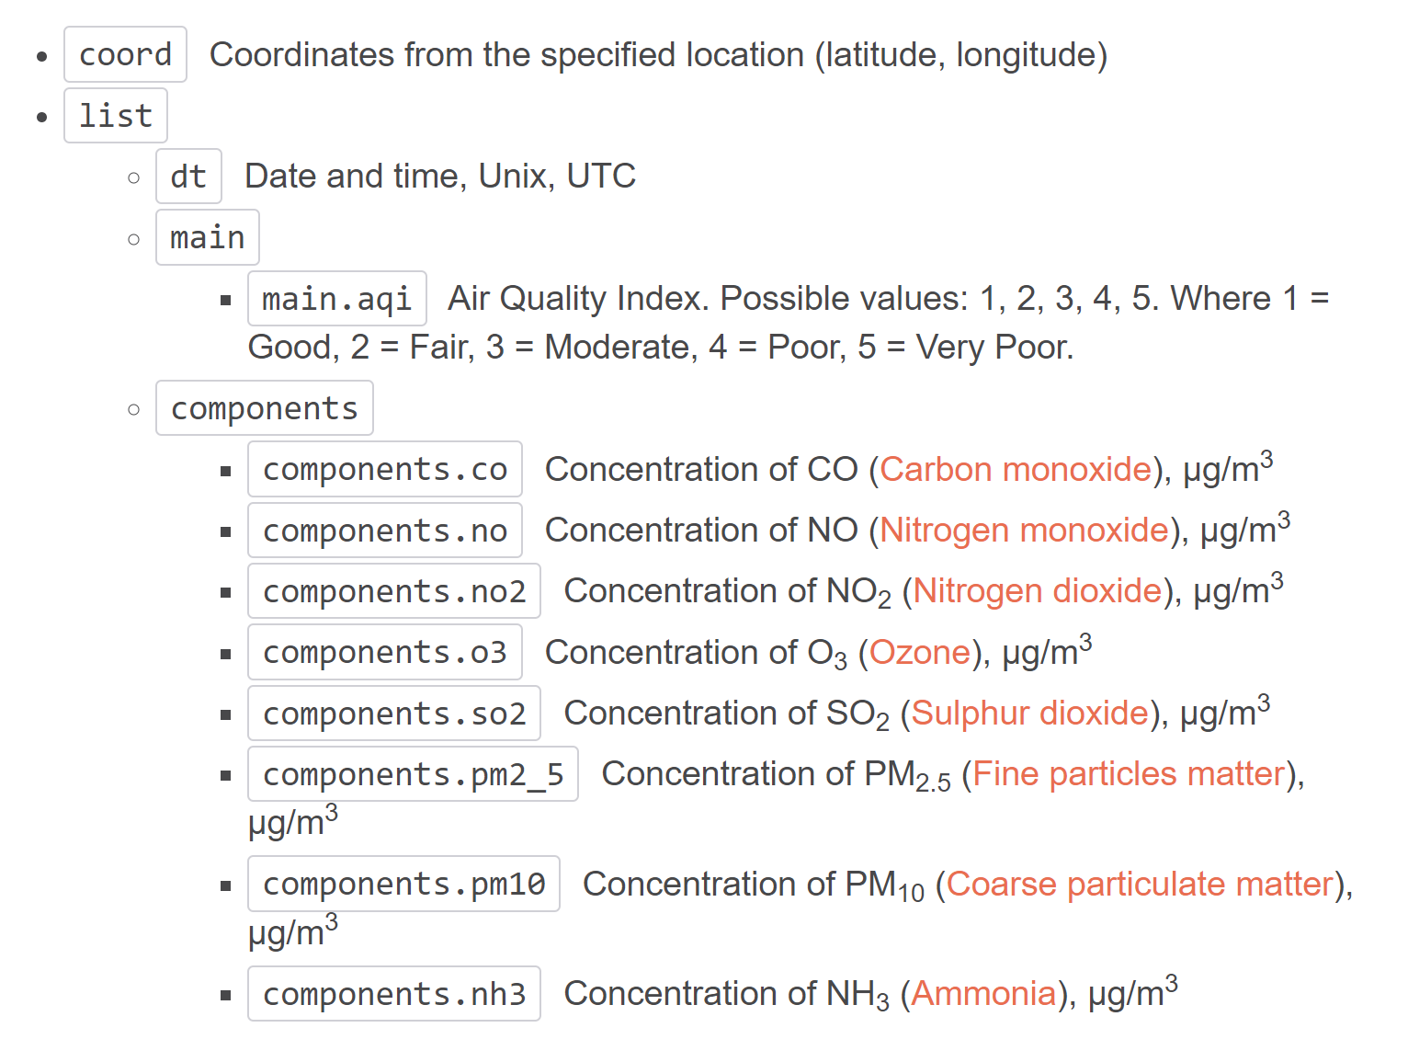

**3 or 4 screenshots of relevant, “inspiring” visualizations that frame your creative fodder**

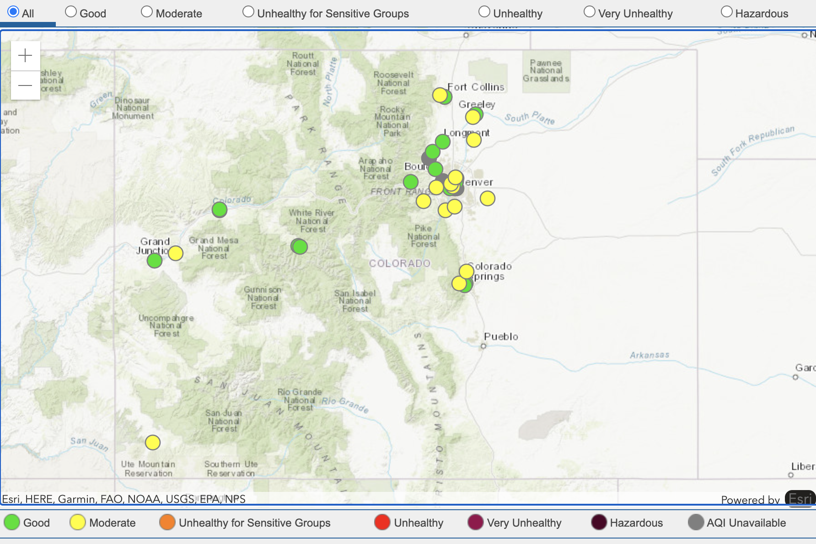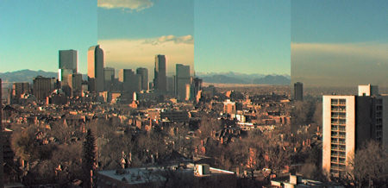

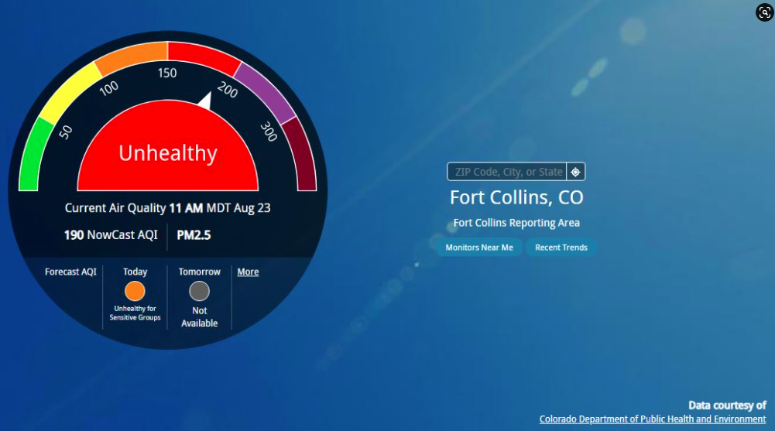

**A sketch of the final design**

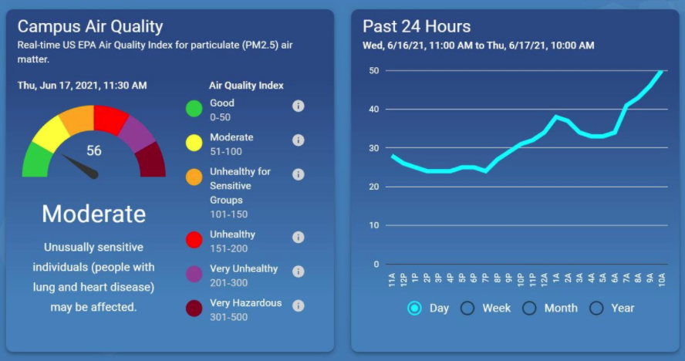

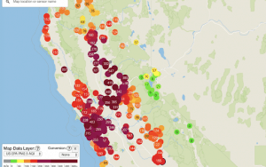

**A link to the primary GitHub repository you’ll be housing your work in**

[**https://github.com/willserene/project2-the-air-we-breath**](https://github.com/willserene/project2-the-air-we-breath)